Janece Gates

Project Two

CS-340 Client/Server Development

December 7, 2022

**Description:**

This is the software application for Grazioso Salvare, designed to facilitate the process of filtering through animal data from the AAC database as it pertains to those suitable for rescue missions. The software has 4 main components: a filtering section, an interactive table section, a dynamic pie chart, and a dynamic map. The filtering section consists of 4 buttons, 3 of which will filter the data based off of the type of rescue which is indicated in text on the button, while the 4th button will simply reset the data to the state it was before any filtering was applied. The interactive data table will display the filtered or unfiltered internal data and the dynamic map will show the location, breed, and name of any row selected in the interactive table. Lastly, the pie chart will also show the distribution of breeds in the underlying filtered or unfiltered data.

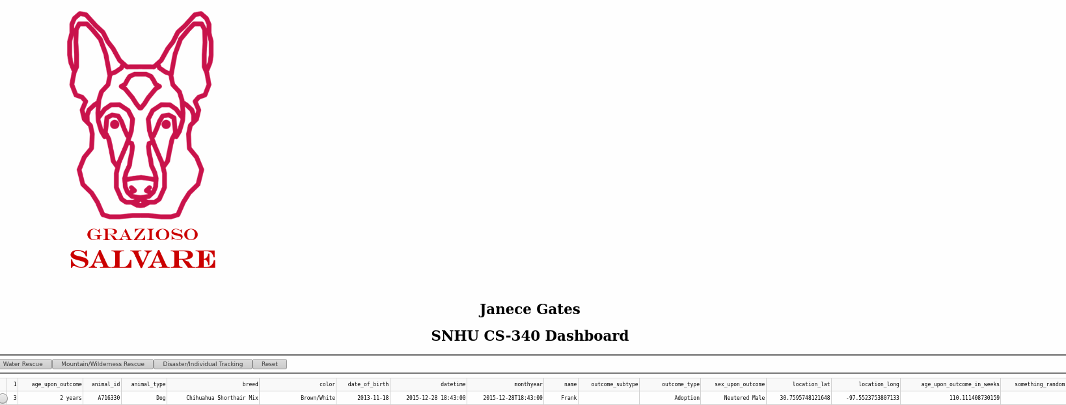

The above screenshot depicts the Grazioso Salvare logo as well as the name of the developer, Janece Gates, as well as the top of the data table.

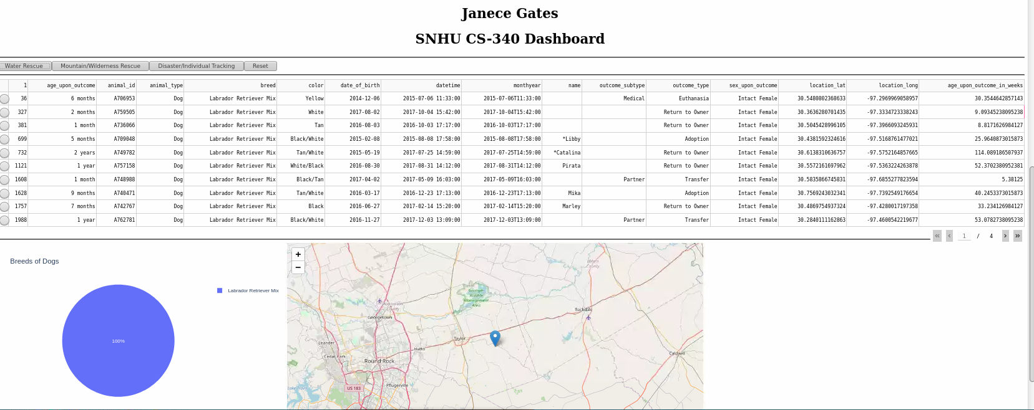

The above screenshot depicts the result of the Water Rescue filtering button being clicked.

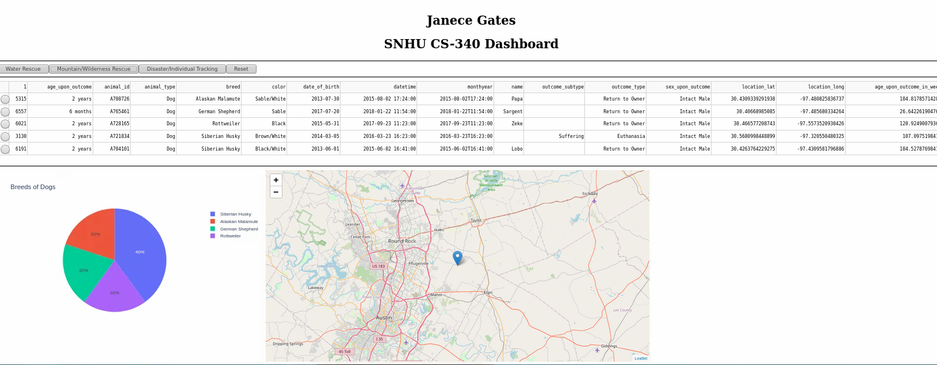

The above screenshot depicts the result of the Mountain/Wilderness Rescue filtering button being clicked.

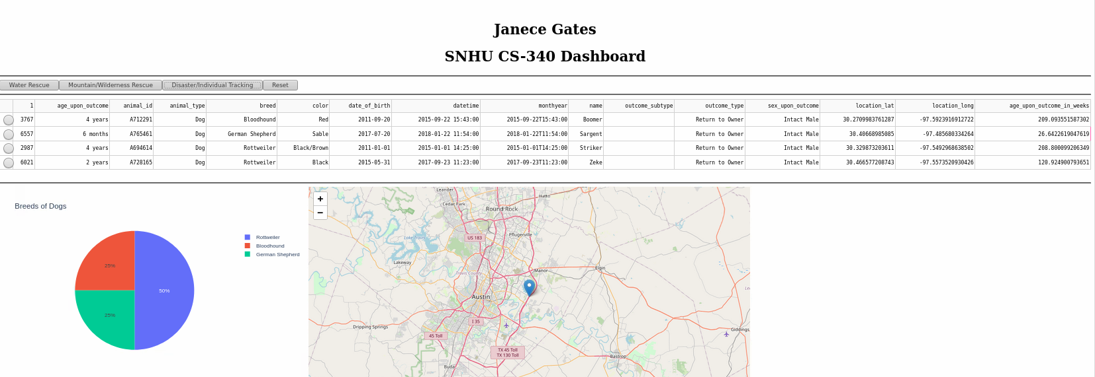

The above screenshot depicts the result of the Disaster/Individual Tracking filter button being clicked.

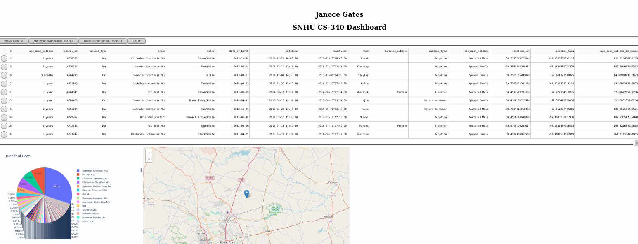

The above screenshot depicts the result of the reset button being clicked.

The tools used for this project were:

* MongoDB
  + This database technology was used to store the animal information.
* PyMongo
  + This library was used to access the Mongo Database’s records.
* Dash
  + This library was used to build/specify the visual and interactive components of the software.

Extensive use of the site <https://plotly.com/> assisted greatly in the implementation of the required features.

Steps taken to complete the project:

* Specify the children of the app.layout and add the Logo, Developer Credit, Filtering Buttons, Data Table, Map, and Pie Chart.
* Specify the callbacks for each of the dynamic elements of the software.

There were no significant challenges encountered during the development of this software.